UPLOAD IMAGE TO CONTAINER REGISTRY

|  |  |
| --- | --- |
| **Team ID** | **PNT2022TMID27314** |
| **Project Name** | **NEWS TRACKER APPLICATION** |

Push the image to the IBM Cloud Registry

1. From your account dashboard, go to **IBM Cloud Kubernetes Service**.
2. From the left navigation menu, select **Private Repositories**.

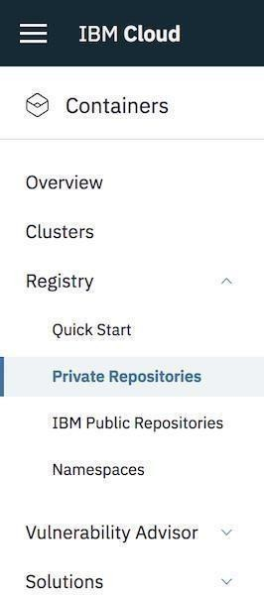

1. Install the Container Registry plug-in.
2. ibmcloud plugin install container-registry -r "IBM Cloud"
3. Log in to your IBM Cloud account.
4. Name and create your namespace. Use this namespace for the rest of the Quick Start.

6. ibmcloud login -a <cloud_foundary_end_point_for_the_region>

1. ibmcloud cr namespace-add <namespace>
2. Log your local Docker daemon into the IBM Cloud Container Registry.
3. ibmcloud cr login
4. Choose a repository and tag by which you can identify the image.
5. docker tag <image_name> <region_url>/<namespace>/<image_name>:<tag>
6. Push the image.
7. docker push <region_url>/<namespace>/<image_name>:<tag>



1. Verify that your image is in your private registry.



16. ibmcloud cr image-list